**ProRide**

TEAM NAME **- CODING BOTS 101**

TEAM MEMBER**-**

**ARNAB PODDAR**

**SHRESTH RAJ**

**MANAV POPLI**

**NIKHAR GANGWAR**

INTRODUCTION

“Why OLA should be the central authority of transaction between customers and drivers?” With this aim we are developing a working prototype model of ProRide which is a taxi ride web application which involve decentralized system of connecting customer directly to drivers wihout involving any middleman.This will help the customers in reduced fair along with some profit sharing directly with the drivers. Here we are using the technologies of Ethereum Blockchain Contracts and Solidity to make payments to the drivers after the completion of ride through customer’s Ethereum wallet.

WORKFLOW OF THE MODEL

The workflow would be like, once the customer enters their starting and destination point in the website the list of available drivers along with their details of car, km rate, time etc. will be shown to the customer. The customer will select most preferable ride and make a payment.

LANDING PAGE



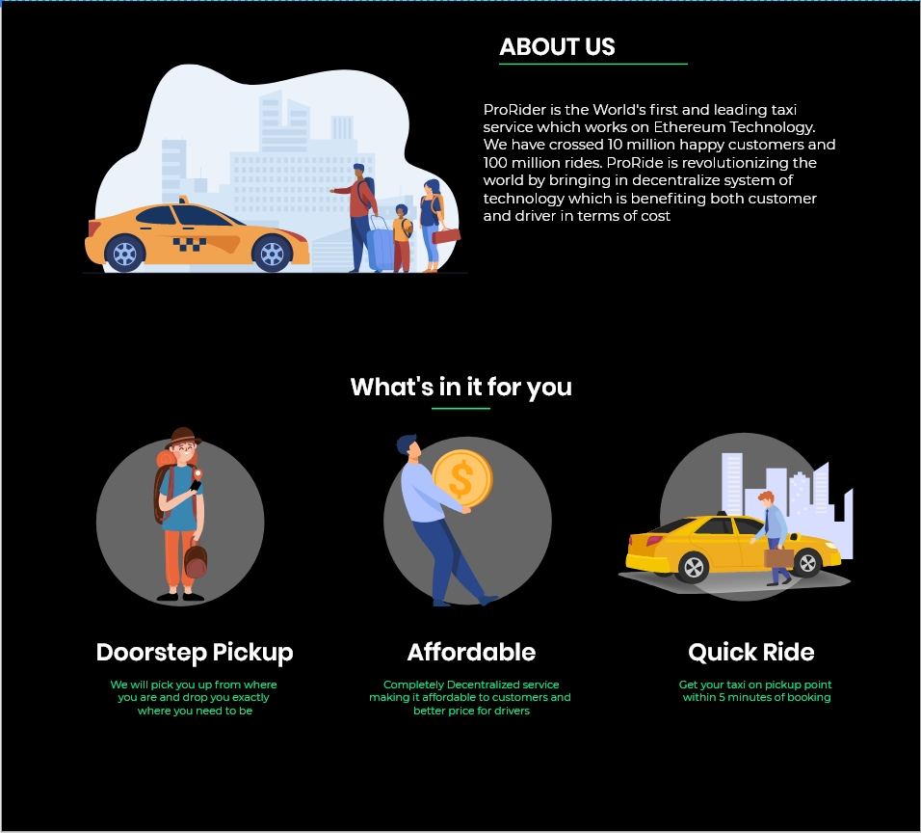

CUSTOMERS BOOKING TAXI

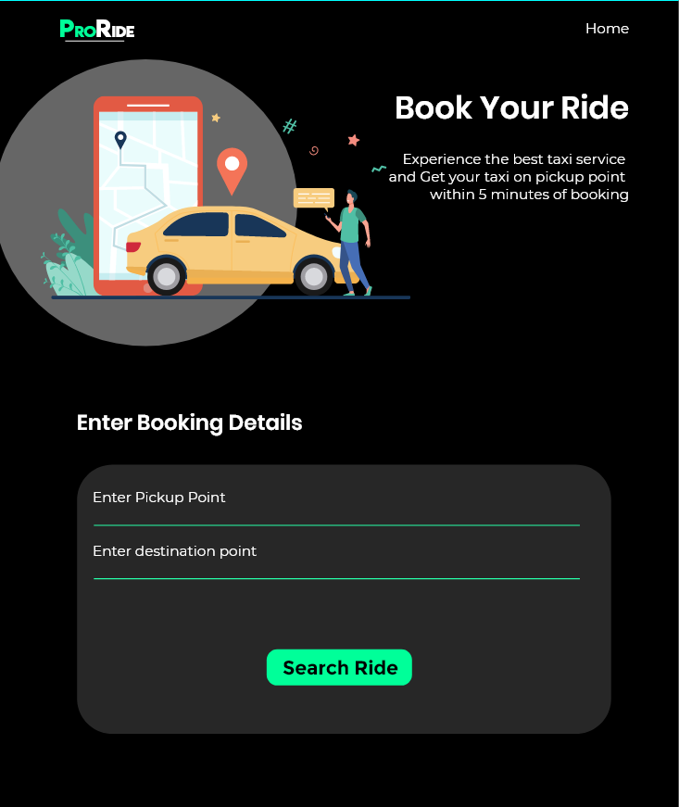

TAXI AVAILABILITY

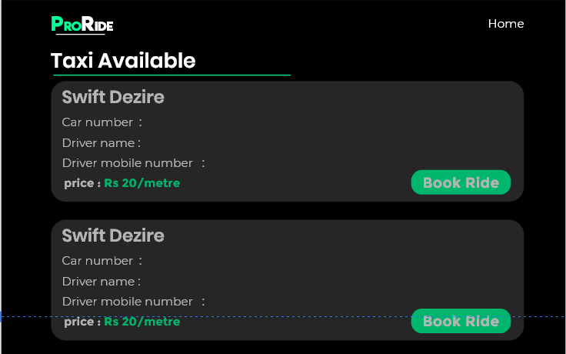

BILL DETAILS

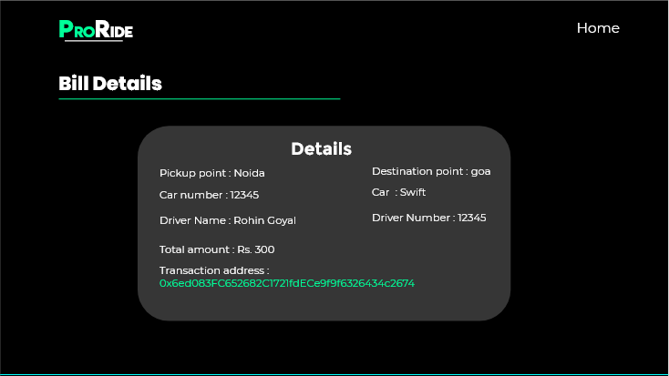

DRIVE A CAR

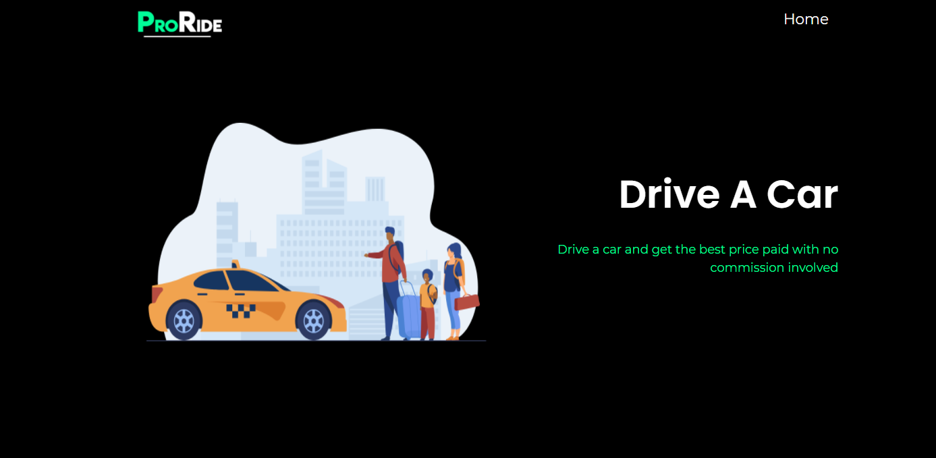

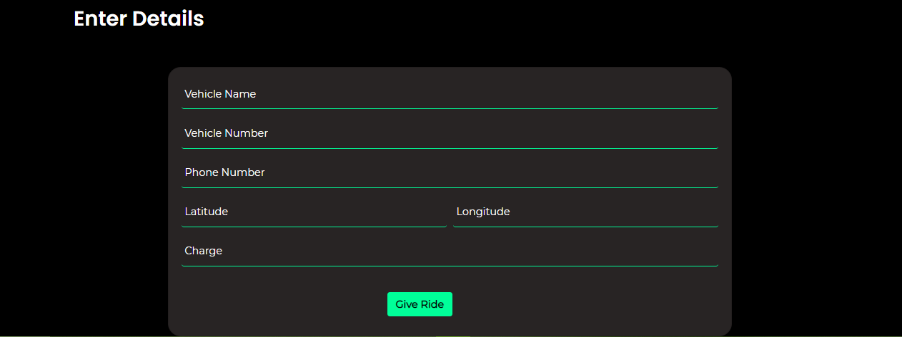

DRIVER DETAIL

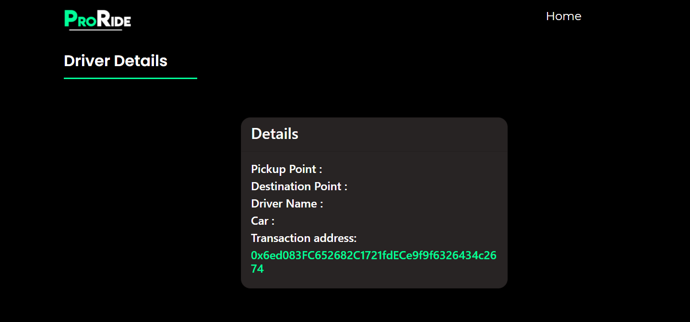

Meta Mask: A crypto wallet & gateway to blockchain apps

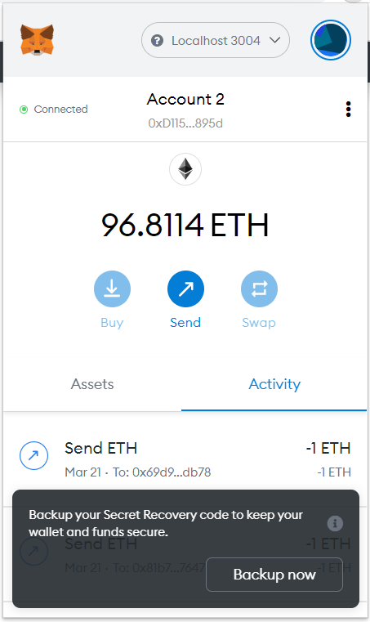

Tools/ Framework used

**-Solidity**

**-Truffle**

**-Node.js**

**-Mongo.db**

**-Express.js**

**-Meta Mask**